Midterm 1

#Karishma Sawant

protein <- read.csv("C:/Users/sawan/OneDrive/Desktop/Backup KPS/Rutgers Courses/Sem 2/MA/Midterm/Protein_Consumption.csv",header=TRUE)

head(protein)

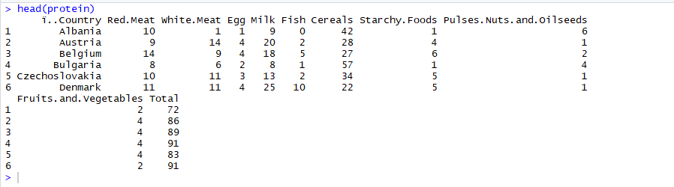

protein<-Protein_Consumption

**#Question 1**

#Use principal components analysis to investigate the relationships

#between the countries based on these variables

#View(protein)

dim(protein)

attach(protein)



#The data set does not contain any categorical values and it also does not contain any missing values

#Removing the last column because it's just sums of all columns across each country

cor(protein[c(-1,-11)])

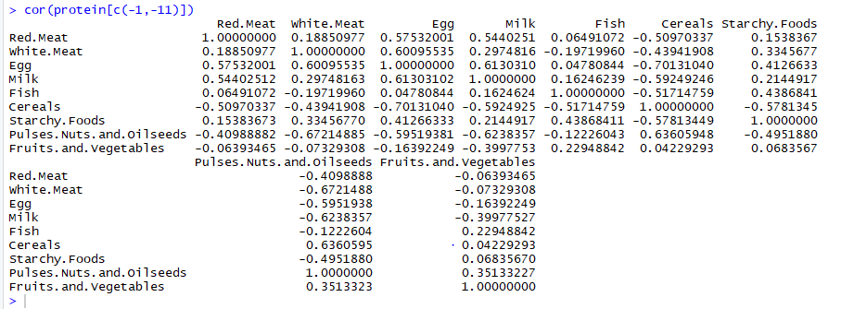

pca <- prcomp(protein[,c(-1,-11)],scale=TRUE)

pca

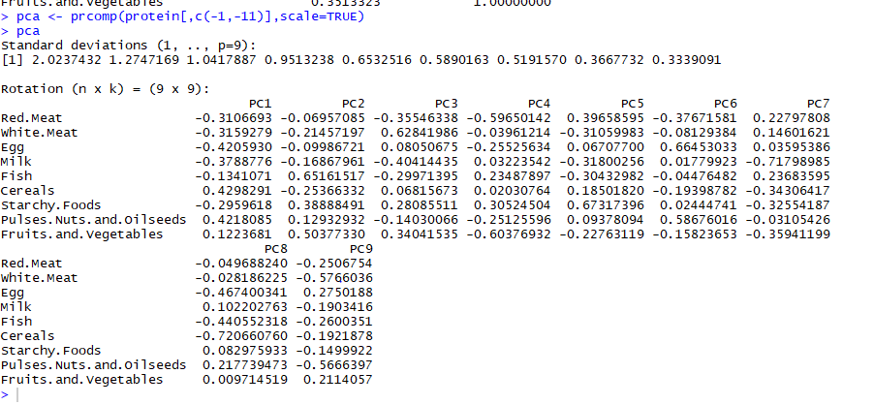

summary(pca)

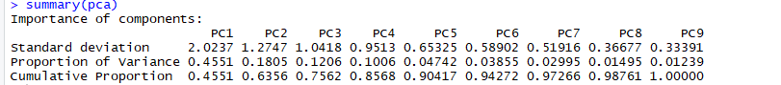

#Reading from the summary of pca table we can see that upto pc5 about 90% of variance is captured

plot(pca) #from the above plot we see that pca1 accounts for maximum variance in the data

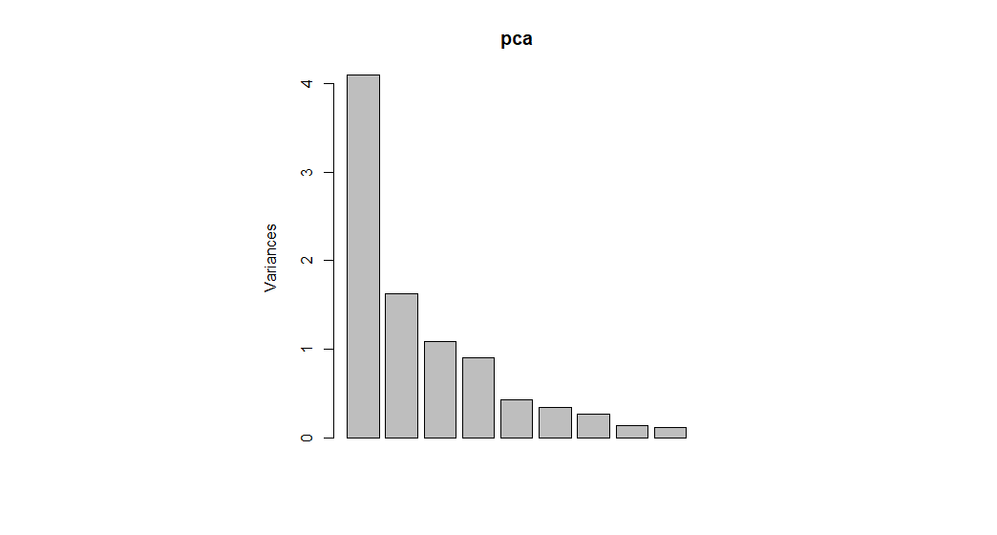

pca$x

pca$x

PC1 PC2 PC3 PC4 PC5 PC6 PC7 PC8

[1,] 3.4062175 -1.43187183 -1.596648133 -0.08434257 0.4124395 -0.2667144820 0.94892837 0.84693053

[2,] -1.3961709 -1.07844406 1.234558817 -0.02919248 -0.7564630 0.0237975418 0.05758584 -0.05177819

[3,] -1.6271911 0.27394175 -0.009163712 -0.41608341 0.9108462 -0.1269263837 0.22683921 -0.22319293

[4,] 3.0996115 -1.50333675 0.082356700 -0.30660707 -0.2970873 -0.5842119100 0.39976618 -0.90940273

[5,] -0.4277883 -0.57418064 1.159335459 0.21991003 0.3701307 -0.7261570266 0.29971869 -0.06798719

[6,] -2.4422594 0.28305004 -0.676942687 1.02016258 -0.6562849 0.0627184045 0.48030200 -0.56925372

[7,] -1.4249913 0.60782538 1.746831101 0.87710306 0.6028516 0.2138448106 0.53117349 -0.18580431

[8,] -1.7006498 -0.58298031 -1.972677332 1.58071748 -0.2011453 -0.2058406000 -0.97347796 0.28022893

[9,] -1.4354297 0.89590251 -0.161539920 -1.95053301 0.3099538 -1.4755527601 -0.03008584 -0.06846045

[10,] 2.3291742 0.86546599 -1.227337046 -1.75741320 -0.6575195 1.0097312103 -0.57538334 -0.34740216

[11,] 1.4302687 -0.95052166 1.782611863 0.26555332 -0.1057918 0.8657732666 0.11900810 0.19668872

[12,] -2.5809791 -0.82037615 -0.161750192 -0.51252848 0.8610870 0.6415595029 -0.43471746 0.03742272

[13,] 1.5501576 0.16192833 -0.053056104 -1.33599650 -0.7676190 0.0312818001 -0.14708797 -0.12872601

[14,] -1.7115591 -0.78012960 0.766301047 -0.25865817 -0.9164207 0.3040553671 0.06091030 0.35043459

[15,] -0.9571511 1.10929163 -1.319851198 1.21615923 -0.4173226 0.0038561601 0.04796743 -0.05700862

[16,] -0.1285106 0.63184836 1.522555810 -0.03104612 -0.1228267 -0.3479854540 -1.31643147 -0.01492251

[17,] 1.8854364 4.23632323 0.235407502 0.64127627 -0.3296311 -0.5280805539 0.53140483 0.20289705

[18,] 2.6361730 -1.10164486 0.169166371 0.60431439 0.1965040 0.1708000230 -0.04058813 -0.17580879

[19,] 1.4042842 2.43957843 0.249276728 -0.24228673 0.6238140 1.0132276525 -0.14851022 0.27557451

[20,] -1.9196053 -0.08881654 -1.085799797 0.90373795 -0.7886161 0.2848678709 0.41870881 -0.19737555

[21,] -0.8862644 -0.79798276 -0.228906351 -1.06865159 -0.7103254 -0.6895174928 -0.21158255 0.59042991

[22,] -1.9396765 -0.32877834 -1.274231236 -1.19215725 1.2311866 0.6339274501 0.43367349 -0.24441516

[23,] 0.8607657 -0.15774231 -0.215679913 1.04275420 1.2112175 -0.5814776989 -0.72141844 -0.05214970

[24,] -1.8007758 -0.34409820 0.872728311 -0.26262846 -0.1813817 0.2726945750 0.39030488 0.53225955

[25,] 3.7769132 -0.96425165 0.162453908 1.07643653 0.1784042 0.0003287263 -0.34700826 -0.01917849

PC9

[1,] 0.15478609

[2,] 0.11624278

[3,] -0.09689498

[4,] 0.25018422

[5,] 0.25074519

[6,] -0.50886295

[7,] 0.29526903

[8,] 0.12113082

[9,] -0.51649154

[10,] -0.45103458

[11,] -0.44150330

[12,] -0.05217871

[13,] 0.85624862

[14,] -0.28870555

[15,] 0.18258443

[16,] 0.31505313

[17,] -0.20295441

[18,] -0.13304725

[19,] 0.36210459

[20,] 0.30259740

[21,] 0.03956071

[22,] 0.13761916

[23,] -0.11645720

[24,] -0.13919641

[25,] -0.43679928

pca.cty <- cbind(data.frame(protein[,1]),pca$x)

pca.cty

protein...1. PC1 PC2 PC3 PC4 PC5 PC6 PC7

1 Albania 3.4062175 -1.43187183 -1.596648133 -0.08434257 0.4124395 -0.2667144820 0.94892837

2 Austria -1.3961709 -1.07844406 1.234558817 -0.02919248 -0.7564630 0.0237975418 0.05758584

3 Belgium -1.6271911 0.27394175 -0.009163712 -0.41608341 0.9108462 -0.1269263837 0.22683921

4 Bulgaria 3.0996115 -1.50333675 0.082356700 -0.30660707 -0.2970873 -0.5842119100 0.39976618

5 Czechoslovakia -0.4277883 -0.57418064 1.159335459 0.21991003 0.3701307 -0.7261570266 0.29971869

6 Denmark -2.4422594 0.28305004 -0.676942687 1.02016258 -0.6562849 0.0627184045 0.48030200

7 East Germany -1.4249913 0.60782538 1.746831101 0.87710306 0.6028516 0.2138448106 0.53117349

8 Finland -1.7006498 -0.58298031 -1.972677332 1.58071748 -0.2011453 -0.2058406000 -0.97347796

9 France -1.4354297 0.89590251 -0.161539920 -1.95053301 0.3099538 -1.4755527601 -0.03008584

10 Greece 2.3291742 0.86546599 -1.227337046 -1.75741320 -0.6575195 1.0097312103 -0.57538334

11 Hungary 1.4302687 -0.95052166 1.782611863 0.26555332 -0.1057918 0.8657732666 0.11900810

12 Ireland -2.5809791 -0.82037615 -0.161750192 -0.51252848 0.8610870 0.6415595029 -0.43471746

13 Italy 1.5501576 0.16192833 -0.053056104 -1.33599650 -0.7676190 0.0312818001 -0.14708797

14 Netherlands -1.7115591 -0.78012960 0.766301047 -0.25865817 -0.9164207 0.3040553671 0.06091030

15 Norway -0.9571511 1.10929163 -1.319851198 1.21615923 -0.4173226 0.0038561601 0.04796743

16 Poland -0.1285106 0.63184836 1.522555810 -0.03104612 -0.1228267 -0.3479854540 -1.31643147

17 Portugal 1.8854364 4.23632323 0.235407502 0.64127627 -0.3296311 -0.5280805539 0.53140483

18 Romania 2.6361730 -1.10164486 0.169166371 0.60431439 0.1965040 0.1708000230 -0.04058813

19 Spain 1.4042842 2.43957843 0.249276728 -0.24228673 0.6238140 1.0132276525 -0.14851022

20 Sweden -1.9196053 -0.08881654 -1.085799797 0.90373795 -0.7886161 0.2848678709 0.41870881

21 Switzerland -0.8862644 -0.79798276 -0.228906351 -1.06865159 -0.7103254 -0.6895174928 -0.21158255

22 United Kingdom -1.9396765 -0.32877834 -1.274231236 -1.19215725 1.2311866 0.6339274501 0.43367349

23 USSR 0.8607657 -0.15774231 -0.215679913 1.04275420 1.2112175 -0.5814776989 -0.72141844

24 West Germany -1.8007758 -0.34409820 0.872728311 -0.26262846 -0.1813817 0.2726945750 0.39030488

25 Yugoslavia 3.7769132 -0.96425165 0.162453908 1.07643653 0.1784042 0.0003287263 -0.34700826

PC8 PC9

1 0.84693053 0.15478609

2 -0.05177819 0.11624278

3 -0.22319293 -0.09689498

4 -0.90940273 0.25018422

5 -0.06798719 0.25074519

6 -0.56925372 -0.50886295

7 -0.18580431 0.29526903

8 0.28022893 0.12113082

9 -0.06846045 -0.51649154

10 -0.34740216 -0.45103458

11 0.19668872 -0.44150330

12 0.03742272 -0.05217871

13 -0.12872601 0.85624862

14 0.35043459 -0.28870555

15 -0.05700862 0.18258443

16 -0.01492251 0.31505313

17 0.20289705 -0.20295441

18 -0.17580879 -0.13304725

19 0.27557451 0.36210459

20 -0.19737555 0.30259740

21 0.59042991 0.03956071

22 -0.24441516 0.13761916

23 -0.05214970 -0.11645720

24 0.53225955 -0.13919641

25 -0.01917849 -0.43679928

library(devtools)

install_github("vqv/ggbiplot")

library(ggbiplot)

ggbiplot(pca,ellipse=TRUE,labels=protein[,1])

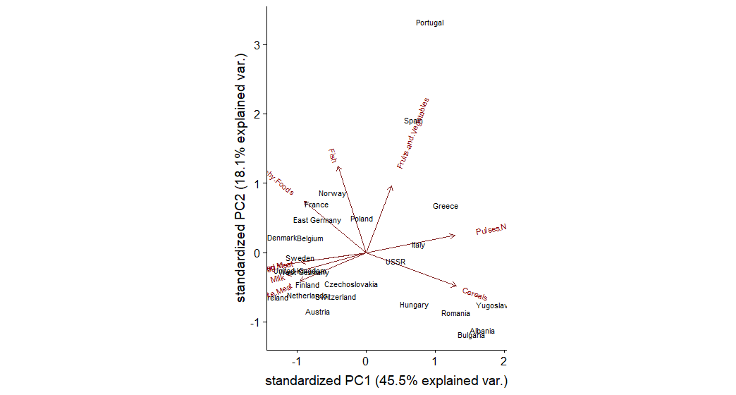

#When we plot the countries and their 2 principal components leading to 54% of variance

#It Shows the concentraion of countries according to the protein consumption from various sources

# 2. Carry out cluster analysis to study relation between countries on their diet

#I will be using agglomerative clustering approach because there are less than 50 points and it's easy to visualize.

#Creating a distant matrix using euclidean distance

row.names(protein) <- protein[,1]

dist.mat <- dist(protein[c(-1,-11)], method="euclidean")

dist.mat

Albania Austria Belgium Bulgaria Czechoslovakia Denmark East Germany Finland

Austria 23.194827

Belgium 21.563859 8.306624

Bulgaria 16.278821 32.756679 33.075671

Czechoslovakia 15.264338 9.848858 10.295630 24.698178

Denmark 30.116441 11.958261 10.862780 40.767634 18.920888

East Germany 22.737634 10.630146 10.000000 33.674916 10.198039 15.748016

Finland 31.288976 17.578396 17.378147 41.255303 23.790755 12.328828 24.454039

France 23.643181 11.180340 5.830952 34.000000 13.266499 12.409674 14.491377 18.055470

Greece 12.449900 20.024984 18.439089 19.748418 15.362291 24.779023 22.538855 24.698178

Hungary 13.000000 16.881943 19.026298 18.708287 9.591663 26.608269 16.911535 30.133038

Ireland 27.784888 10.000000 9.219544 38.794329 17.117243 9.110434 16.703293 11.618950

Italy 10.488088 14.899664 13.820275 21.283797 8.660254 21.886069 15.842980 24.186773

Netherlands 28.495614 6.928203 9.949874 39.230090 16.031220 8.306624 13.228757 15.459625

Norway 26.664583 13.527749 10.488088 38.548671 18.000000 6.928203 15.165751 12.328828

Poland 17.464249 10.049876 12.083046 24.939928 7.874008 18.055470 14.352700 20.149442

Portugal 22.891046 22.891046 19.313208 33.600595 18.947295 24.020824 15.198684 31.511903

Romania 10.816654 25.709920 26.267851 8.246211 18.000000 33.704599 26.795522 34.234486

Spain 16.881943 17.635192 14.142136 29.495762 13.190906 21.118712 11.916375 26.645825

Sweden 29.933259 12.884099 11.532563 41.725292 19.773720 4.358899 16.217275 11.532563

Switzerland 24.657656 7.483315 7.681146 35.623026 14.177447 10.049876 15.066519 13.076697

United Kingdom 24.494897 12.489996 6.403124 37.080992 15.842980 11.090537 15.132746 15.459625

USSR 11.401754 18.973666 18.466185 16.822604 12.688578 25.436195 21.470911 25.159491

West Germany 28.774989 9.486833 9.746794 40.632499 16.401219 10.148892 10.908712 18.947295

Yugoslavia 15.968719 32.046841 32.741411 5.656854 24.494897 39.824616 33.075671 39.673669

France Greece Hungary Ireland Italy Netherlands Norway Poland Portugal

Austria

Belgium

Bulgaria

Czechoslovakia

Denmark

East Germany

Finland

France

Greece 18.920888

Hungary 21.725561 15.231546

Ireland 10.246951 23.259407 24.879711

Italy 15.652476 8.426150 10.630146 20.099751

Netherlands 12.041595 24.596748 23.259407 7.211103 20.149442

Norway 13.114877 21.633308 25.179357 11.357817 18.841444 11.618950

Poland 14.000000 12.489996 11.661904 16.217275 8.660254 15.842980 16.733201

Portugal 22.022716 22.472205 21.886069 27.276363 18.275667 24.979992 20.124612 21.189620

Romania 27.928480 13.784049 11.916375 31.764760 14.525839 32.046841 31.272992 17.776389 27.802878

Spain 17.606817 16.733201 16.431677 21.748563 11.532563 20.518285 16.792856 15.165751 8.774964

Sweden 13.747727 25.317978 27.404379 8.944272 22.000000 8.602325 5.567764 19.000000 24.124676

Switzerland 8.306624 20.174241 21.794495 5.099020 16.492423 6.782330 11.090537 13.228757 24.939928

United Kingdom 7.681146 21.189620 24.145393 7.483315 17.720045 11.224972 10.535654 16.941074 23.151674

USSR 19.974984 8.774964 12.206556 23.280893 9.591663 24.738634 23.000000 10.723805 24.372115

West Germany 12.609520 26.362853 24.062419 9.797959 20.976177 5.291503 12.288206 18.027756 22.847319

Yugoslavia 34.205263 18.708287 17.720045 38.039453 20.760539 38.379682 37.255872 23.748684 32.787193

Romania Spain Sweden Switzerland United Kingdom USSR West Germany

Austria

Belgium

Bulgaria

Czechoslovakia

Denmark

East Germany

Finland

France

Greece

Hungary

Ireland

Italy

Netherlands

Norway

Poland

Portugal

Romania

Spain 22.759613

Sweden 34.452866 20.663978

Switzerland 28.722813 19.313208 9.899495

United Kingdom 30.380915 17.804494 10.392305 7.874008

USSR 9.949874 18.411953 26.229754 20.736441 22.181073

West Germany 33.481338 18.947295 9.695360 9.695360 10.862780 26.532998

Yugoslavia 6.633250 28.425341 40.632499 35.028560 36.783148 15.524175 39.962482

#Invoking hclust using single linkage

dist.nn <- hclust(dist.mat, method = "single")

Call:

hclust(d = dist.mat, method = "single")

Cluster method : single

Distance : euclidean

Number of objects: 25

plot(as.dendrogram(dist.nn),ylab="Distance between countries",main="Dendogram")

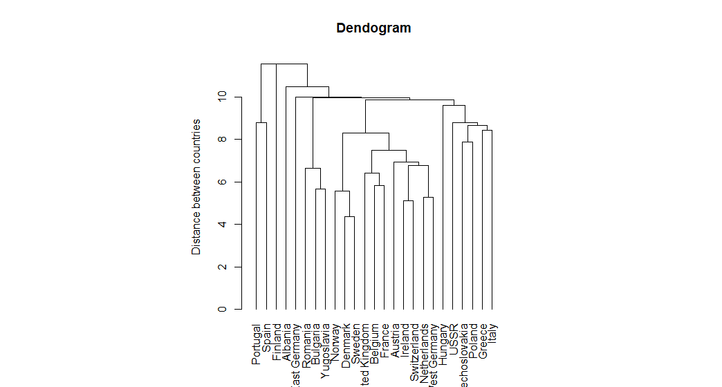

# From the plot we can see various clusters

#Note: Portugal and spain are clustered in 1 and scandinavian nations are clustered in 1.

# 3. Identify the important factors underlying the observed variables and examine the relationships between the countries with respect to these factors

library(psych)

#Do an eigen value decomposition removing the last column

pc <- principal(protein[c(-1,-11)], nfactors=4, rotate="varimax")

pc

Principal Components Analysis

Call: principal(r = protein[c(-1, -11)], nfactors = 4, rotate = "varimax")

Standardized loadings (pattern matrix) based upon correlation matrix

RC3 RC1 RC2 RC4 h2 u2 com

Red.Meat 0.08 0.92 0.01 0.02 0.86 0.138 1.0

White.Meat 0.94 0.14 -0.08 -0.01 0.91 0.086 1.1

Egg 0.59 0.66 0.13 -0.09 0.81 0.193 2.1

Milk 0.20 0.68 0.21 -0.51 0.81 0.188 2.3

Fish -0.21 0.10 0.92 0.09 0.91 0.089 1.2

Cereals -0.42 -0.56 -0.61 0.07 0.87 0.133 2.8

Starchy.Foods 0.52 0.01 0.71 0.03 0.77 0.226 1.8

Pulses.Nuts.and.Oilseeds -0.69 -0.34 -0.28 0.41 0.83 0.166 2.6

Fruits.and.Vegetables -0.05 -0.04 0.14 0.95 0.93 0.071 1.1

RC3 RC1 RC2 RC4

SS loadings 2.25 2.21 1.89 1.36

Proportion Var 0.25 0.25 0.21 0.15

Cumulative Var 0.25 0.50 0.71 0.86

Proportion Explained 0.29 0.29 0.25 0.18

Cumulative Proportion 0.29 0.58 0.82 1.00

Mean item complexity = 1.8

Test of the hypothesis that 4 components are sufficient.

The root mean square of the residuals (RMSR) is 0.05

with the empirical chi square 4.94 with prob < 0.55

Fit based upon off diagonal values = 0.98

summary(pc)

#From the summary we can see that upto 4 factors the variables explain about 86% of the variance

round(pc$values, 3)



pc$loadings

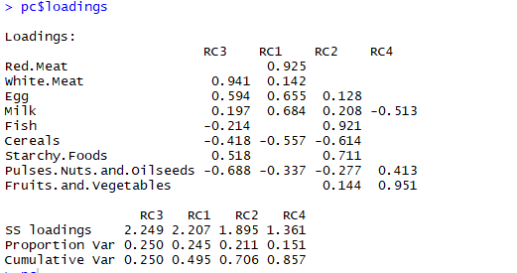

# Communalities

pc$communality

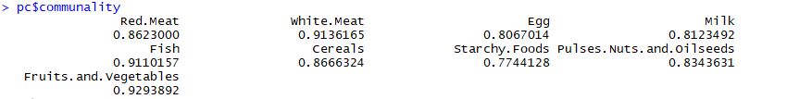

#We can see that fish,white meat and fruits&vegetables account for most common variance among the countries.

fa.parallel(protein[-1]) # See factor recommendation

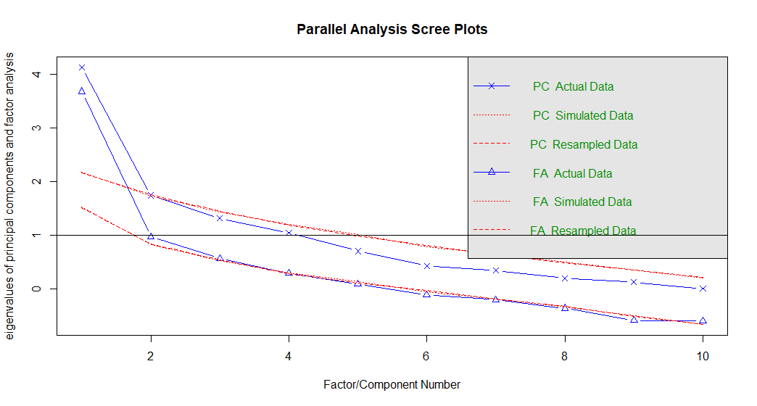

## Parallel analysis suggests that the number of factors = 1 and the number of components = 1

#From the above plot of "PC Actual Data" we can see that after 4 factors the eigen value crosses at 1 and hence 4 is the number of recommended factors

fa.plot(pc) # See Correlations within factor

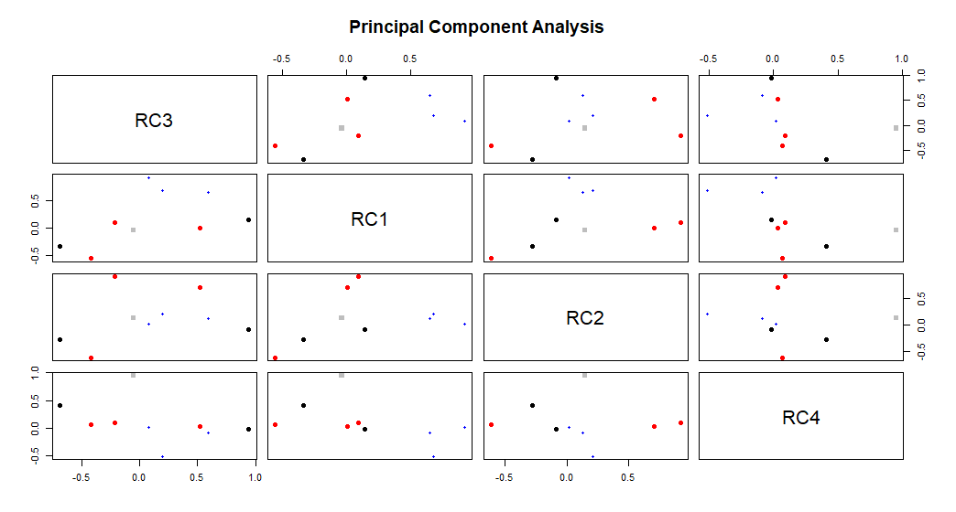

fa.diagram(pc) # Visualizing the relationship

